Lab 6 - API Gateway Pattern & Security
Contents
1. Cover Page 1
2. Abstract / Summary 1
3. Lab-Specific Section: API Gateway Pattern & Security 1
3.1 Document 1: Security Stub Implementation (Token Validation) 1
3.2 Document 2: Routing and Forwarding Logic 2
3.3 Document 3: Execution and Verification (Testing Scenarios) 3
4. Conclusion & Reflection 5

Cover Page
• Title: API Gateway Pattern & Security
• Course Info: Software Architecture
• Student Details: [NGUYEN QUE BAC], [23010574]; [HOANG TUAN KIET], [23010517]; [DO BAO LONG], [23010561]
• Date: January 26, 2026

Abstract / Summary
Lab 06 focuses on implementing the API Gateway Pattern within a Modular Monolith architecture to manage and secure internal communication. Although the system shares a single Laravel codebase, we logically separated its functionalities into two modules running on different ports: the Gateway (Port 5000) and the Movie Service (Port 5001). The Gateway acts as a Single Entry Point, centralizing critical non-functional requirements such as a Security Stub for token validation and Role-Based Access Control (RBAC) to restrict administrative operations like POST, PUT, and DELETE. Furthermore, we enhanced system Resilience by designing exception-handling mechanisms that return a 503 Service Unavailable status during backend failures, ensuring system stability and a professional user interface.

3. Lab-Specific Section: API Gateway Pattern & Security

3.1 Document 1: Security Stub Implementation (Token Validation)
To meet the Architecture Security Requirement (ASR), we developed a centralized security layer within the Gateway module (Port 5000). The primary objective is to authenticate users at the "perimeter" before any requests are forwarded to the Movie module (Port 5001), effectively safeguarding internal logic from unauthorized access.
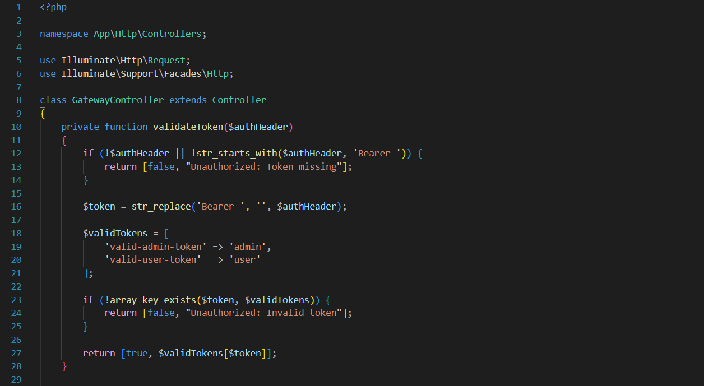
Figure 3.1: Implementation of the validateToken function as a Security Stub in GatewayController
- Token Verification: The Gateway extracts the Bearer token from HTTP request headers. If the header is missing or invalid, it immediately triggers a 401 Unauthorized response, blocking the request from proceeding further.
- Role-Based Access Control (RBAC): By mapping tokens to specific roles (e.g., Admin or User), the Gateway enforces permission boundaries. This allows the system to block regular users from performing administrative actions, such as adding or deleting movies, directly at the entry point.
- Encapsulation: This implementation ensures that the Movie module remains focused on business logic rather than session management. By offloading token validation to the Gateway port, we adhere to the principle of separation of concerns, even within a unified codebase.

3.2 Document 2: Routing and Forwarding Logic
The API Gateway acts as a Reverse Proxy, serving as the intermediary that forwards client requests to the internal Movie module (Port 5001). This mechanism ensures that the internal module's location and structure are completely transparent to the client. By using Laravel's built-in HTTP client, the Gateway replicates the client's original intent—including the HTTP method, headers, and request body—and transmits it to the target backend port.
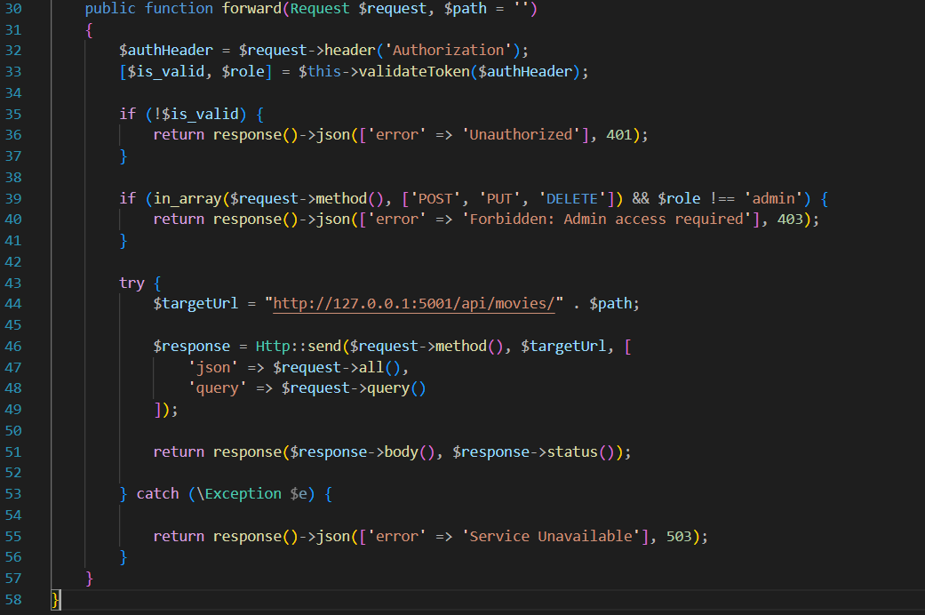
Figure 3.2: Implementation of the request forwarding logic and exception handling in GatewayController.
- Request Mirroring: The Gateway captures the exact HTTP method (GET, POST, etc.) and payload from the client, ensuring that the Movie module receives the correct data without the client ever knowing the internal port (5001).
- Transparency: From the client's perspective, they are only interacting with the entry point at 127.0.0.1:5000. The Gateway handles the complexity of routing the request to the appropriate logic within our modular structure.
- Cross-Origin Isolation: By centralizing routing at the Gateway level, we can manage headers, logging, and CORS policies in one place, rather than duplicating these configurations across every module in the application.

3.3 Document 3: Execution and Verification (Testing Scenarios)
In this section, we performed various test scenarios to verify the interaction between the Gateway module (Port 5000) and the Movie module (Port 5001) within our modular architecture.
Scenario 1: Unauthorized Access (401 Unauthorized)
A request is sent to the Gateway via http://127.0.0.1:5000/api/movies without any authentication token. The Gateway's security stub immediately intercepts the request. Since the Authorization header is missing, the Gateway denies access and returns a 401 Unauthorized status. This demonstrates the "Security First" approach, where the Gateway acts as a shield, ensuring that unauthenticated requests never reach the internal Movie logic.
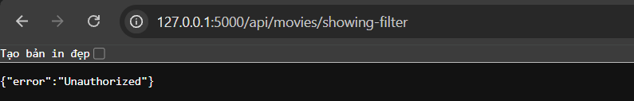
Figure 3.3.1: The API Gateway blocking an unauthenticated request and returning a JSON error message.
Scenario 2: Successful Request Forwarding (200 OK)
A request is sent to the Gateway with a valid authentication token. The Gateway's security logic validates the token and identifies the user’s role. Since the request is authorized, the Gateway performs its function as a Reverse Proxy: it forwards the request to the internal Movie module running on http://127.0.0.1:5001. The module processes the request and returns the movie list data, which the Gateway then proxies back to the client. This confirms that the internal routing and forwarding logic are fully operational.
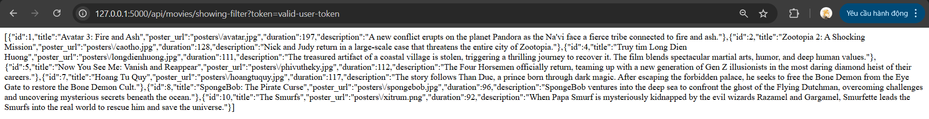
Figure 3.3.2: The Gateway successfully authorized the token and retrieved data from the internal Movie Service.
Scenario 3: Role-Based Access Control (403 Forbidden)
This scenario demonstrates the Gateway's ability to enforce Role-Based Access Control (RBAC). A request is sent with a valid user token, but it attempts to perform an action that requires Admin privileges. Even though the token is valid, the Gateway identifies that the user's role is insufficient. Instead of forwarding the request to the Movie module, the Gateway terminates the request and returns a 403 Forbidden status, protecting the internal logic from unauthorized actions.
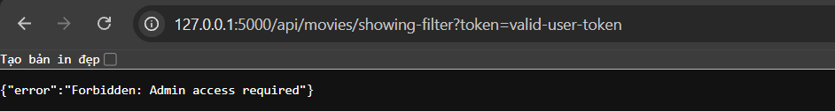
Figure 3.3.3: The Gateway denying access to a restricted resource based on the user's role.

Scenario 4: Service Resilience and Error Handling (503 Service Unavailable)
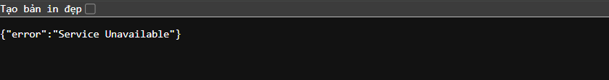
This scenario tests the system's resilience when an internal module is offline. The Movie module process (Port 5001) is intentionally shut down while the Gateway remains active. When a request is sent, the Gateway attempts to connect to the internal port but fails. The Gateway gracefully handles this exception by returning a 503 Service Unavailable status. This prevents the system from exposing raw PHP error details and informs the user that the specific module is temporarily down, ensuring a professional and secure error-handling mechanism.
Figure 3.3.4: The Gateway providing a graceful error response when the backend service is offline

4. Conclusion & Reflection
Lab 06 successfully established a secure and resilient entry point for our Laravel-based system by implementing an API Gateway on port 5000. By adopting a Modular Monolith approach, we were able to simulate a distributed environment while maintaining a unified codebase, effectively decoupling client requests from internal service logic. This exercise demonstrated the importance of centralizing security enforcement through RBAC and improving fault tolerance with graceful error handling. Overall, the implementation provided a robust foundation for managing cross-cutting concerns within a single application framework, bridging the gap between traditional monoliths and modern architectural patterns.

